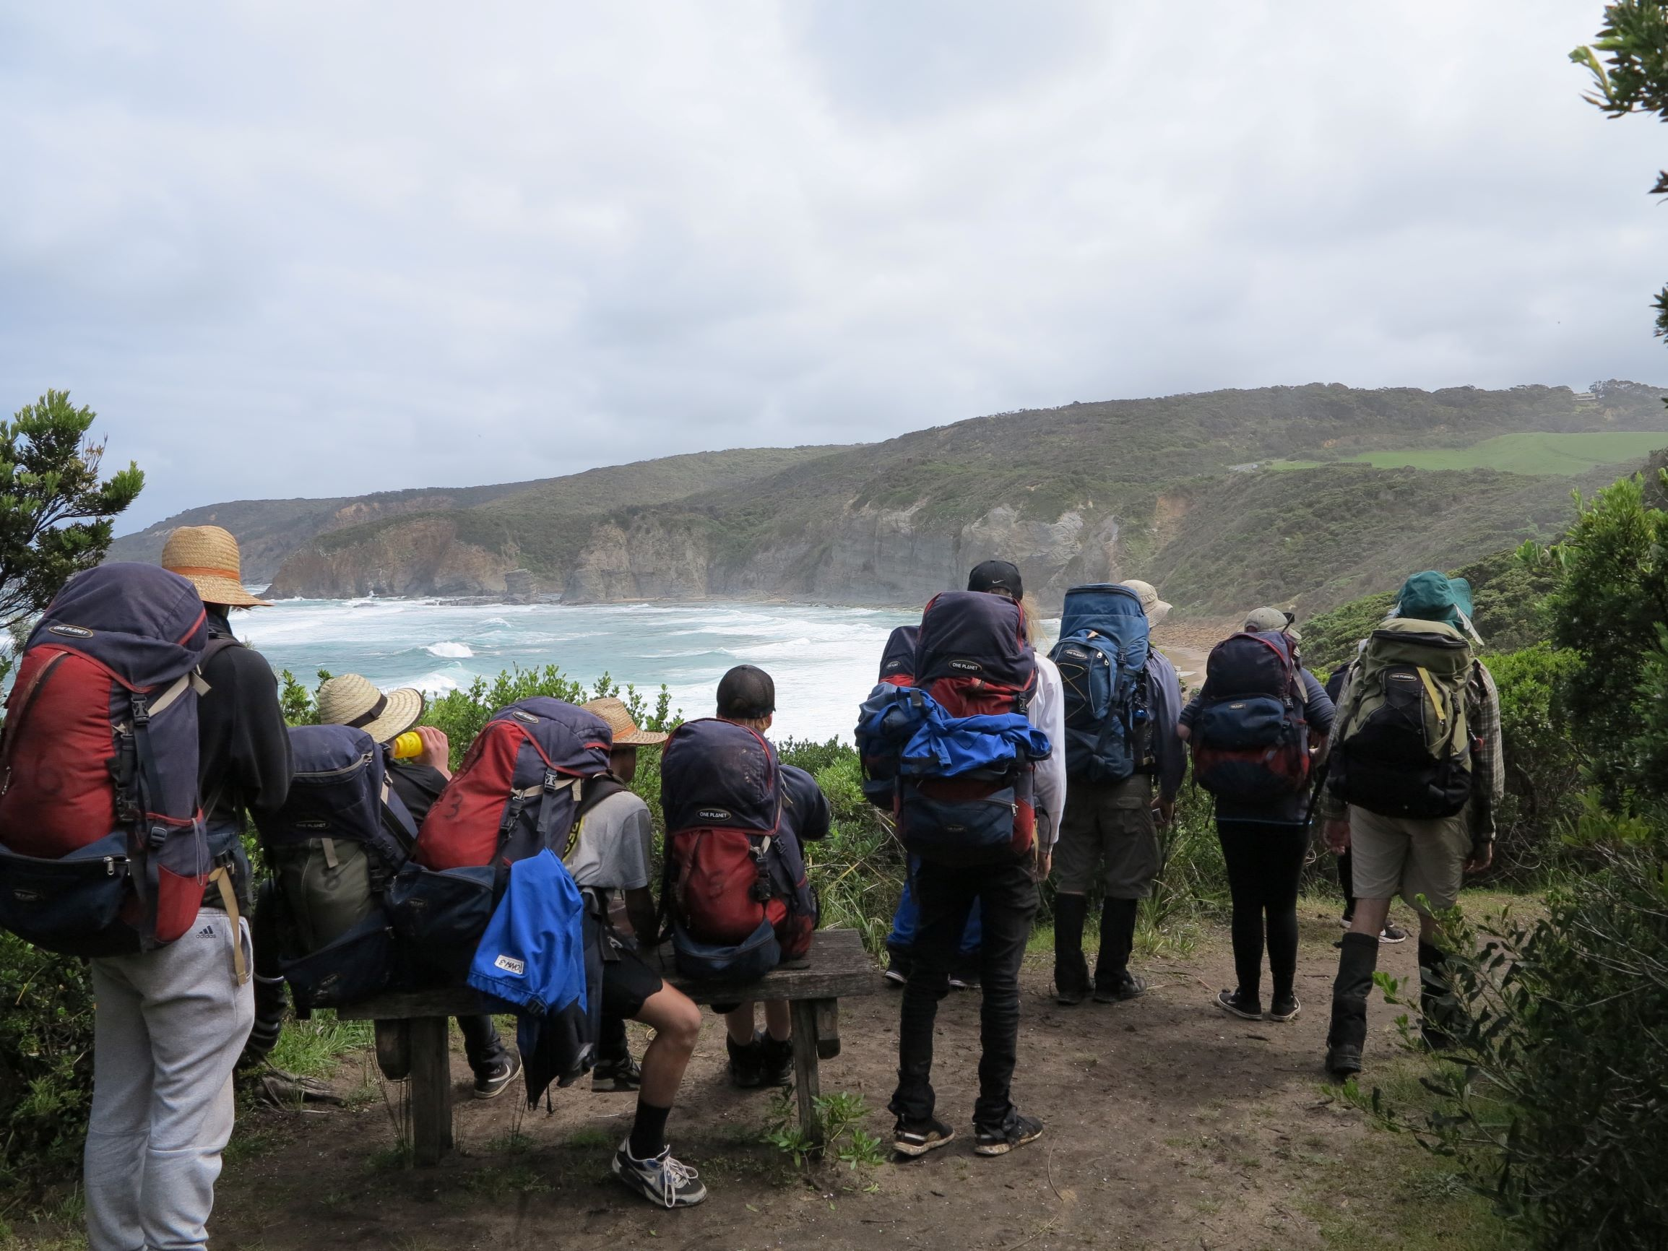  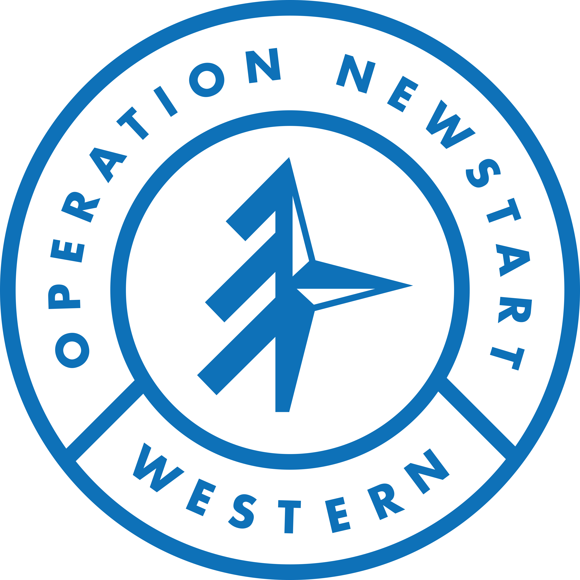  TERM 1 2020  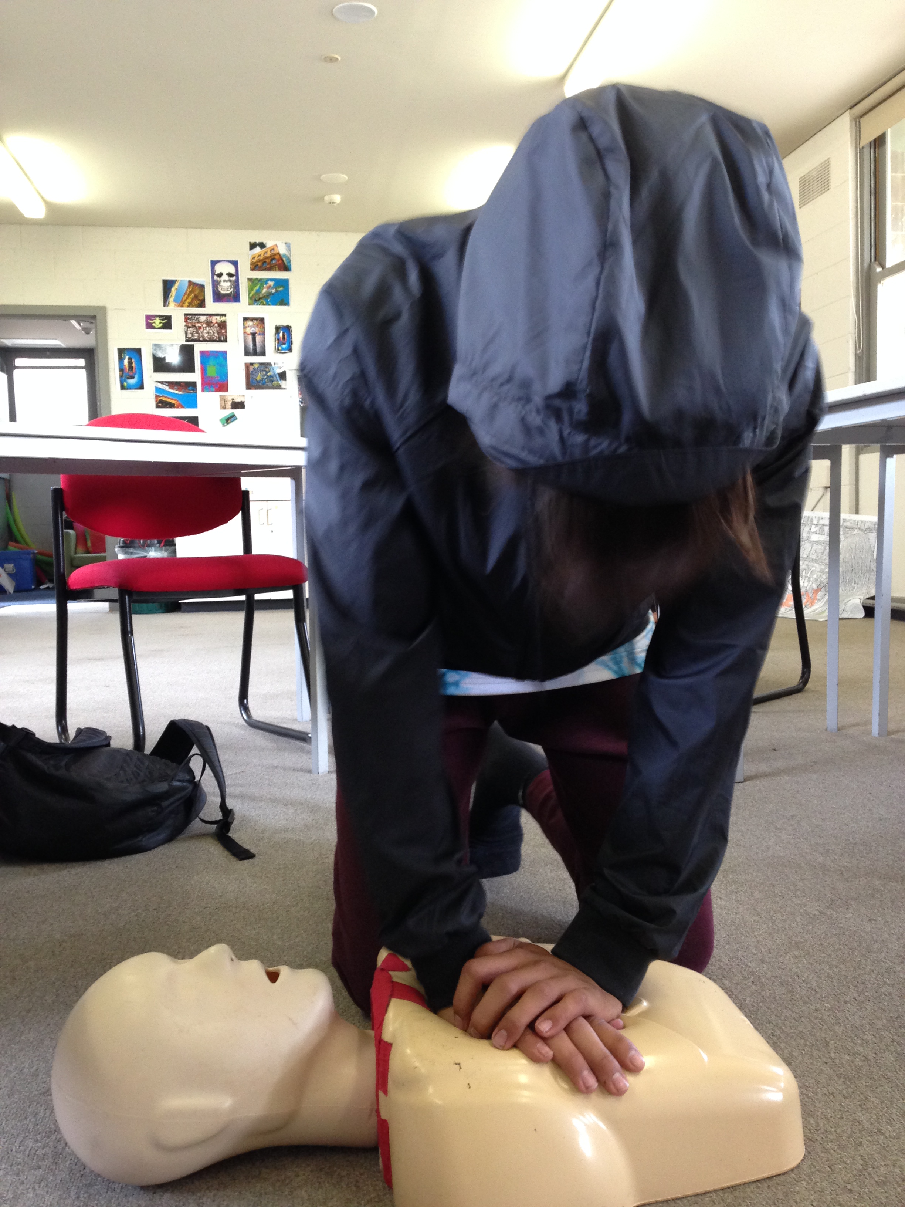  operation newstart western  A CHANCE FOR CHANGE & NEW CONNECTIONS  For those who recognise the need for change and a commitment to doing something about it.  Through outdoor adventure, vocational experiences & involvement in the community, we can help build your capacity to succeed, develop connection in your life and find the motivation to get back on track.  The program runs for 7 weeks over the term. 2 days at School & 3 days on program. If you’re interested, get in touch with us through your school (Year level coordinator or SWC) and they’ll help you with an application. | 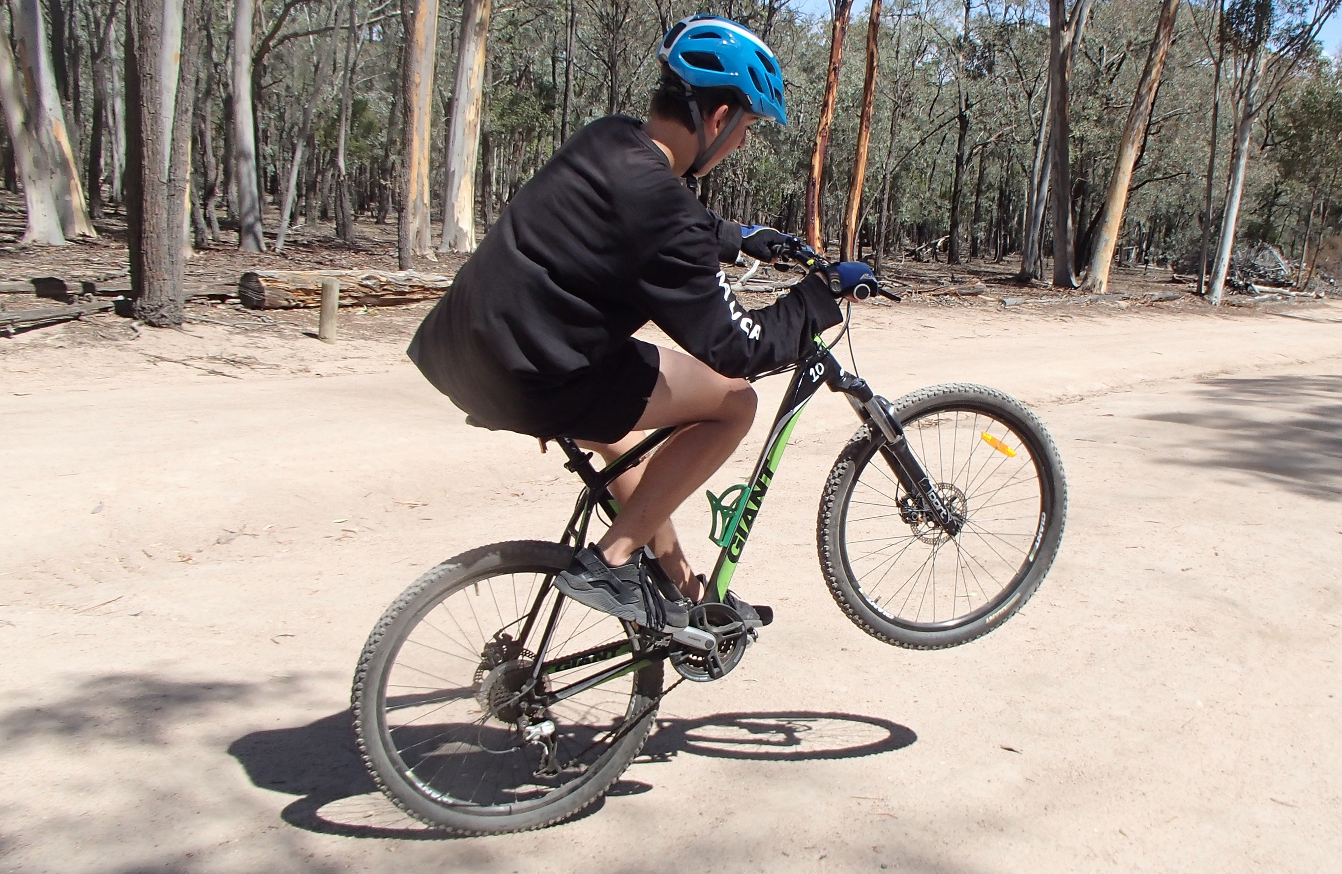  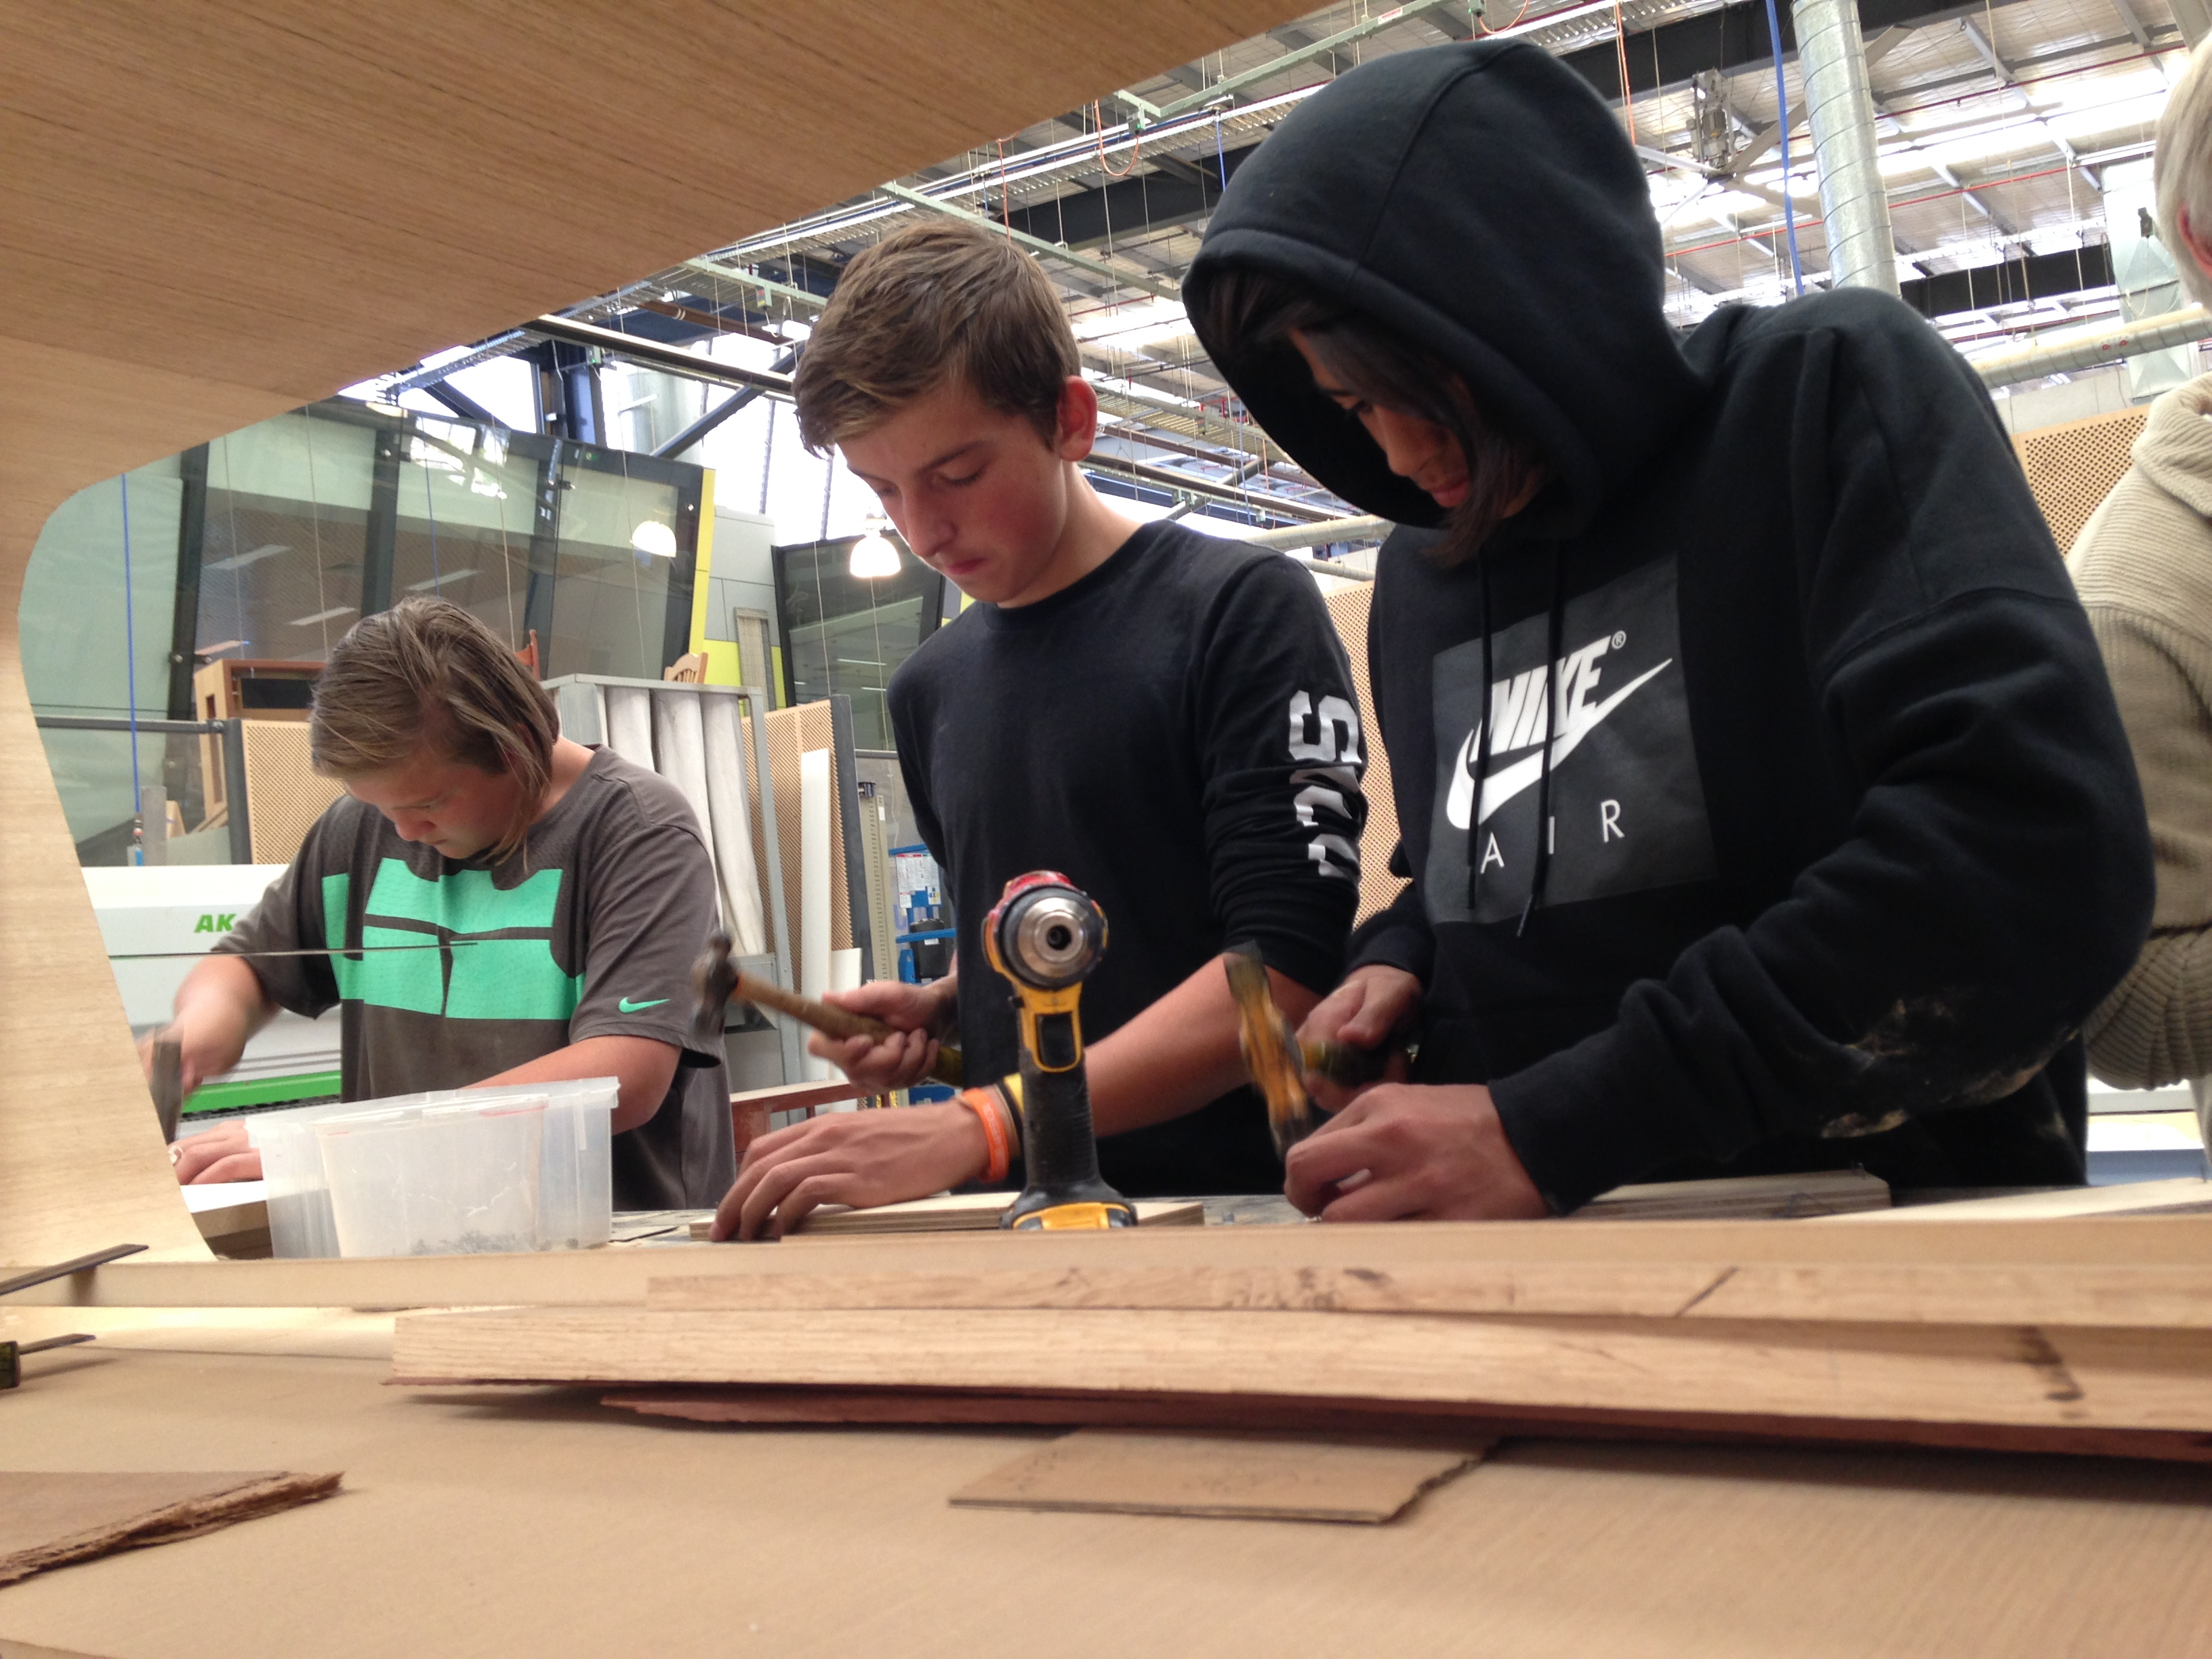  FOR  Young people in Western Metro Government Schools aged 13-16 yrs.  WHY  Having trouble engaging with school and want to get back on track.  HOW  Applications are accepted from schools on behalf of the young person.  COST $800  Schools pay a program fee. No cost to student/family.  WHEN  Interviews 9th-12th December  Program dates: 11th February – 20th March  For more info: contact program facilitators  Jane Beattie: 0439145602  Beattie.jane.j@edumail.vic.gov.au  Shane Le Fevre: 0448314412  Lefevre.shane.s@edumail.vic.gov.au

OPERATION NEWSTART WESTERN
School | Holidays | Newstart | Camp | Parent involvement

Month | Mon | Tue | Wed | Thu | Fri
Jan  2019 | 21 | 22 | 23 | 24 | 25
 | 28 | 29 | 30  SAMPLE PROGRAM | 31 | 1
Feb  2019 | 4 | 5 | 6 | 7 | 8
 | 11 | 12 | 13 | 14  PARENT INFO SESSION | 15  INTRO DAY  CAMP PREP
 | 18 | 19 | 20  GREAT OCEAN WALK | 21  GREAT OCEAN WALK | 22  GREAT OCEAN WALK
 | 25 | 26 | 27  CAMP CLEAN & REVIEW  PARENT EVENING | 28  COFFEE ACADEMY | 1  PATH OF THE HORSE
Mar  2019 | 4 | 5 | 6  YOU YANGS (MTB) | 7  REACH | 8  FAMILY CHALLENGE DAY
 | 11 | 12 | 13  FIRST AID | 14  SURFING | 15  CAMP PREP
 | 18 | 19  LOWER GLENELG EXPEDITION | 20  LOWER GLENELG EXPEDITION | 21  LOWER GLENELG EXPEDITION | 22  LOWER GLENELG EXPEDITION
 | 25 | 26 | 27  CLEAN UP & REVIEW | 28  EVALUATION & GRAD PREP  BOXING | 29  GRADUATION
 | 31 | 1 | 2 | 3 | 4

