

**iLead is a leadership program for Year 9 students who have been nominated by their school as potential leaders.** iLead focuses on enhancing the student’s leadership skills through a range of outdoor and community activities. The 8 students will work together to further develop their leadership skills through a range of outdoor activities, practical skills & community involvement.

The iLead program is run during Term 3 each year by the Travancore School. Unlike the Operation Newstart program which targets students deemed to be at ‘significant educational risk’, the iLead program instead focuses on providing students opportunity to **enhance their leadership capabilities.**

The aims of the program are to;

* Enhance self-awareness through investigating strengths, weaknesses, beliefs and values.
* Develop effective communication skills, including public speaking.
* Develop personal skills in goal setting, reflection, and positive wellbeing.
* Understand how effective teams work and demonstrate capacity to work well with others.

The program will run Wednesday to Friday (3 days per week) for 5 weeks, commencing on Friday 2nd of August and concluding with a graduation ceremony on Thursday 5th of September.

The student attends their normal school on Mondays and Tuesdays throughout the program.

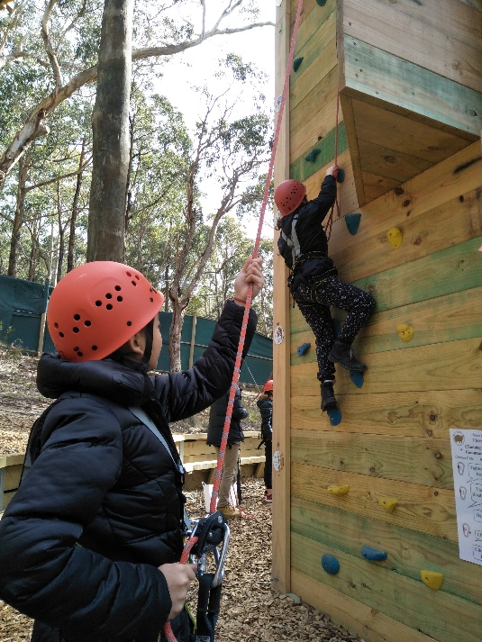There is no cost to the students and their families. **The referring school pays a program fee of $500 per student.**

The types of activities that students will be participating in during the program include:

* Leadership activities at Rubicon Outdoor Education Centre
* 3 day snow camp at Mt Buller
* Community project work
* First aid course
* Leadership development activities
* Outdoor adventure activities (mountain biking, skiing/snowboarding, rafting).

**Comments from previous students:**

* “I’ve gained more confidence in speaking to others”
* 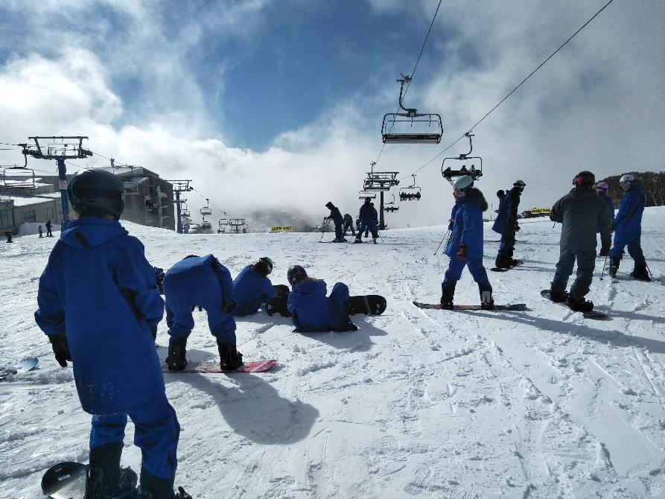“The skiing camp helped me achieve my goals. That’s when I thought to myself if I push myself to do something, I can do it”
* “What helped was the support of my peers. They never said anything negative”
* “I have definitely gained more leadership skills which have helped me to become a better leader”
* “Meeting great people was fun”

**Comments from a referring school:**

* “We had four students go through the program in 2015 and it was a great success - a couple are now House Captains in their final year at school”

**If you’re interested in participating in the iLeaD program, we’d love to hear a bit more from you.**

**Name : ____________________________________________________**

**Why would you like to be considered for iLead?**

_______________________________________________________________________________________________________________________________________________________________________________________________________________________________________________________________________________________________________________________________________________

**What skills would you like to improve on during your Term in the iLead program?**

_______________________________________________________________________________________________________________________________________________________________________________________________________________________________________________________________________________________________________________________________________________

**What skills do you bring to the iLead program?**

_______________________________________________________________________________________________________________________________________________________________________________________________________________________________________________________________________________________________________________________________________________

**Have you ever been to the snow before? Yes / No**

**Do you have any concerns about participating in iLead during Term 3?**

_________________________________________________________________________________________________________________________________________________________________________________________________________

**Do you have any other comments or questions you would like to add?**

____________________________________________________________________________________________________________________________________________________________________________________________________________________________________________________________________________

Thanks for taking the time to apply for the iLeaD program and tell us more about yourself.

Once completed, please return to your school representative (teacher) who will attach it to your application.

We will be in touch with school representatives to finalise positions for the program before the winter school holidays.