Operation Newstart Western

“Enhancing the lives of, and giving future direction to young people at risk”

Travancore School
50 Flemington St, Travancore, Victoria 3032
P: 03 9345 6053 F: 03 9345 6052

Program Facilitators
Shane Le Fevre: 0448 314 412 Shane.Lefevre@education.vic.gov.au
Paul Stafford: 0439 145 602 paul.stafford@education.vic.gov.au
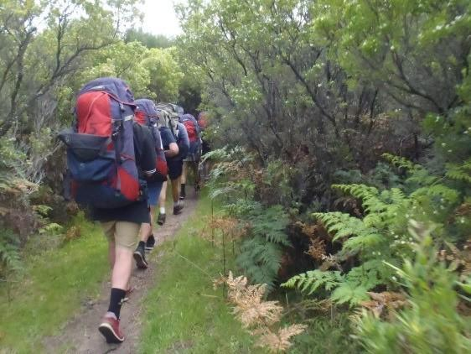
The Operation Newstart Western (ONW) program is providing for young people aged between 13 & 16 who attend a Government school in the Western Metropolitan area of Melbourne.

Purpose:

ONW is an experiential & skills based program, helping young people to improve connection with their education and to take ownership of their future direction. It’s a fantastic opportunity for those who recognise the need for change and a commitment to doing something about it.

Aims:
- To provide students with unique learning opportunities in a range of environments which creatively challenge and motivate them.

- To assist students in developing tangible skills which promote their sense of individual achievement, self-confidence and self-awareness.

- To build positive connections between the young person and their family, school and community.

Application process:
Schools complete an application form and submit it to the Travancore School by emailing the program facilitators in the preceding term. Applications can be found on the Travancore School website. An interview between the student, their parent/carer, school staff and ONW staff will be used to determine the suitability of the program for the young person.

Program Location:
Operation Newstart is based at the Travancore School which is situated in the inner western suburb, Travancore. On program days, students will meet ONW staff at Footscray Station, where they will be transported by mini bus to the relevant activity. Interviews and Parent Sessions take place at the Travancore School.

Program:
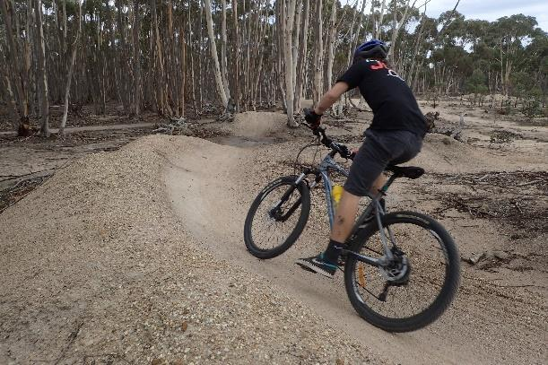
Eight students are involved in the program for 7 weeks over the school term, and maintain contact with their school two days a week (Monday and Tuesday). Core elements which contribute to the program’s success are:
• Adventure activities & Camps
• Personal Development & Life Skills
• Future focus & Vocational Orientation
• Community Involvement
• Family Involvement
• Partnerships with School, during & after the program

Camps:
There are 2 camps in each program:
• 3-day introductory trip
- 3-4 day expedition

Both camps are integral to program outcomes. The first camp that students attend is focused around building relationships with their peers and the program facilitators as well as learning about the group dynamics and the different leadership roles they may adapt throughout the program. It is also an important opportunity for students to familiarise themselves with the goals they have chosen and to start working towards achieving those goals.

The second camp is considered to be a major milestone towards successfully graduating from the program. The nature and context of Expedition means the student group takes more responsibility in running the camp with staff deliberately stepping back to allow this process to occur. Due to this increased responsibility, students will be ‘invited’ if they demonstrate the following:
• Safety for self and others.
• Attempts to work positively in a team; adhering to the agreed group values.
• Able to take responsibility for their own actions.
• A willingness to listen and respond to feedback; given by staff and peers.

Equipment:
Students will be given an Equipment List on the first day of the program. All specialist equipment will be provided by ONW. It will be the student’s responsibility to take care of their allocated equipment.

Fees:
The fees charged cover the costs during program, including equipment and activities. This fee ($800) will be invoiced to the student’s base school. Families will be required to cover the cost of transport to and from Footscray Station and the student’s lunches (this excludes camp meals which are covered by the program fee).

Family Sessions:
We know that families who positively support their young person during the program assist with successful outcomes. Such support takes many forms and will be discussed further in the interview and family sessions. Whilst each student will need to demonstrate commitment to the program, so do their families. There are a number of sessions that families commit to attending as part of the Newstart program:

- Interview: with student, family member & school staff member, at Travancore School. (1 hr)
- Parent & Student Information Day at Travancore School (2 hrs)
- Family Evening Session at Travancore School (2 hrs)
- Family Challenge Day at Blackwood (5 hrs)
- Graduation Ceremony at Kensington Town Hall (2 hrs)

Successful Completion & Graduation:
A Graduation Ceremony will be held at the conclusion of the program to celebrate the achievements of students who successfully complete the 7-week program. Families and School staff are invited to attend this celebration. Details regarding the Graduation will be communicated to families and schools.
Students who meet the requirements of the program rubric will receive a Graduation certificate and students who do not meet the requirements will receive a Participation certificate. The program rubric takes into account the students; participation, engagement, attendance & goal progress.

Transition Back to School:
A major objective of the ONW program is to improve the student’s engagement with their education. To assist with this process, ONW staff will visit the student’s school to work with both the student and staff to identify strengths, areas of concern and support strategies in the development of a formal Individualised Learning Plan (ILP).
At the conclusion of the program ONW staff will write an Education report for each student, and conduct a transition meeting, focusing on transferring the terms learning to the school context.

Consent and Evaluation Forms:
Once students have been selected for the program, parent/carers and students will be asked to fill out a number of forms including consent and medical forms before commencement of the program.
A variety of forms and surveys will be given to students, parents/carers and school staff in order to assist us in measuring outcomes for students.

Student Expectations
Students participating in the program are expected to act in a manner conducive to the wellbeing of property, other people and the natural environment. Students & parents/carers will be guided through the expectation agreement, which will need to be accepted and signed before the commencement of program.

Further Information:
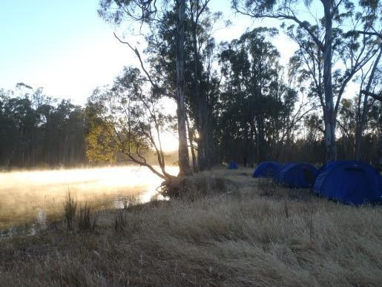
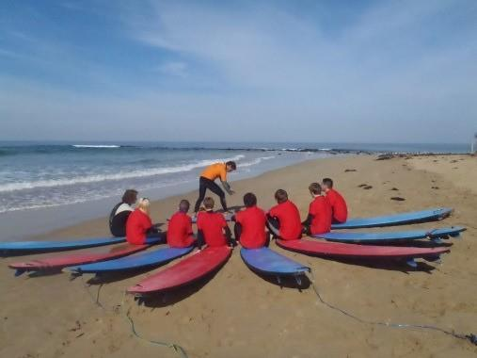
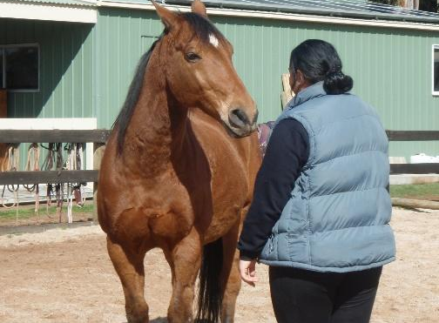
If you require further information about the program, please go to our page on the Travancore School website or contact one of the facilitators (details on the front page of booklet).

STUDENT EXPECTATIONS

Operation Newstart, while recognising the importance of the development of the individual, emphasises the need for each participant to work towards developing a strong supportive team. This team approach is vital to the success of the program.

Our school has a duty of care to all students, and to provide a safe and secure learning environment.

- To attend the Operation Newstart Western program Wednesday to Friday (or otherwise stated)
- To attend school on Monday and Tuesdays (I will provide a medical certificate for all absences). If the student does not provide a medical certificate, they will need to make up for their non-attendance by attending a day at their referring school.
- All absences caused by external suspensions will also need to be made up for by attending their referring school before returning to program.
- To be punctual to all meeting places (I understand that if late ring/text before the organised meeting time)
- To behave safely and responsibly (including travelling to and from program)
- To support and respect the rights of others
- To respect and care for all equipment/property (personal, school & others) and the environment
- To follow the instructions of the Facilitators and specialised instructors
- To participate to the best of my ability in activities
- To hand in any prohibited items at the beginning of each day
- To secure my phone in a Yondr pouch for the duration of the day/camp.
- To refrain from consuming energy & soft drinks
- To refrain from taking drugs and alcohol (including tobacco)
- To refrain from coarse language (swearing)

The facilitators, in consultation with relevant personnel (e.g. Principal) may deal with any breaches in student behaviour that compromises the safety of others by imposing appropriate consequences which may include exclusion from activity/event or program

