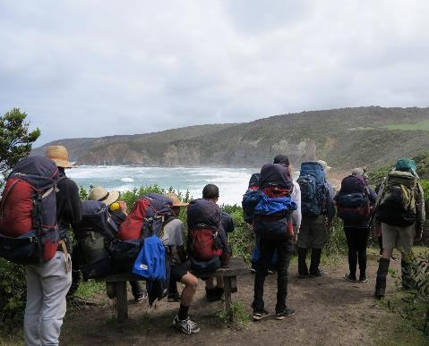  TERM 2 2021  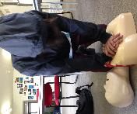  operation newstart western  A CHANCE FOR CHANGE & NEW CONNECTIONS  For those who recognise the need for change and a commitment to doing something about it.  Through outdoor adventure, vocational experiences & involvement in the community, we can help build your capacity to succeed, develop connection in your life and find the motivation to get back on track.  The program runs for 7 weeks over the term. 2 days at School & 3 days on program. If you’re interested, get in touch with us through your school (Year level coordinator or SWC) and they’ll help you with an application. | 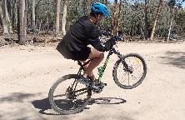  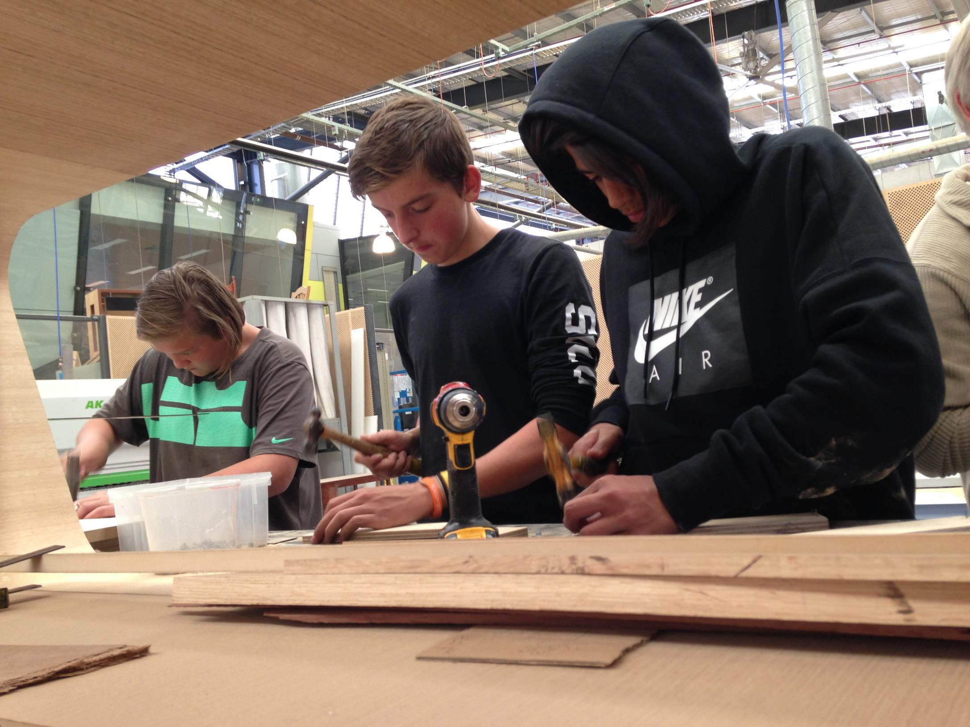  FOR  Young people in Western Metro Government Schools aged 13-16 yrs.  WHY  Having trouble engaging with school and want to get back on track.  HOW  Applications are accepted from schools on behalf of the young person.  COST $800  Schools pay a program fee. No cost to student/family.  WHEN  Interviews:  19th – 23rd April  Program dates:  30th April – 18th June  For more info: contact program facilitators  Shane Le Fevre: 0448314412  Shane.Lefevre@education.vic.gov.au  Paul Stafford: 0439 145 602  Paul.stafford@education.vic.gov.au

NEWSTART WESTERN  CALENDAR. Term 1 2020 | School | Holidays | Newstart | Camp

Month | Mon | Tue | Wed | Thu | Fri
Jan  2021 | 18 | 19 | 20 | 21 | 22
 | 25 | 26 | 27 Term 1 start | 28 First student day | 29
 | 1 | 2 | 3 | 4 | 5
Feb  2021 | 8  Parent info session | 9 | 10  Intro Day  Camp pack  SAMPLE PROGRAM | 11  Narana & Surfing | 12  Huddle & VU Polytechnic
 |  | 16  School meetings | 17 Intro camp | 18 Intro camp | 19 Intro camp
 | 22 | 23 | 24 Camp clean  Boxing  Parent evening | 25  Reach | 26  Path of the Horse
 | 1 | 2 | 3  MOTLEY | 4  First Aid | 5  Family Challenge Day
Mar  2021 | 8 | 9  School meetings | 10  MTB You Yangs | 11  Reach | 12  Rosamond & Camp pack
 | 15 | 16  Expedition | 17  Expedition | 18  Expedition | 19  Expedition
 | 22 | 23 | 24  Camp clean  Boxing | 25  Grad prep | 26  Graduation
 | 29 | 30  Transition meetings | 31  Transition meetings | 1 | 2

